**DAILY ONLINE ACTIVITIES SUMMARY**

|  |  |  |  |  |  |  |  |
| --- | --- | --- | --- | --- | --- | --- | --- |
| **Date:** | **2/06/2020** | | | | **Name:** | **Bhuvana S** | |
| **Sem & Sec** | **8th A** | | | | **USN:** | **4AL16CS022** | |
| Online Test Summary | | | | | | | |
| **Subject** | | **----** | | | | | |
| **Max. Marks** | | **----** | | **Score** | | **-------** | |
| Certification Course Summary | | | | | | | |
| **Course** | **Introduction to Ethical Hacking** | | | | | | |
| **Certificate Provider** | | | **Great learning** | **Duration** | | | **254 mins** |
| Coding Challenges | | | | | | | |
| **Problem Statement-**: c++ prog to find sum of digits until the number is a single digits | | | | | | | |
| **Status: Solved** | | | | | | | |
| **Uploaded the report in Github** | | | | **YES** | | | |
| **If yes Repository name** | | | | **bhuvanashivakumar** | | | |
| **Uploaded the report in slack** | | | | **YES** | | | |

**Certification Course Details:**

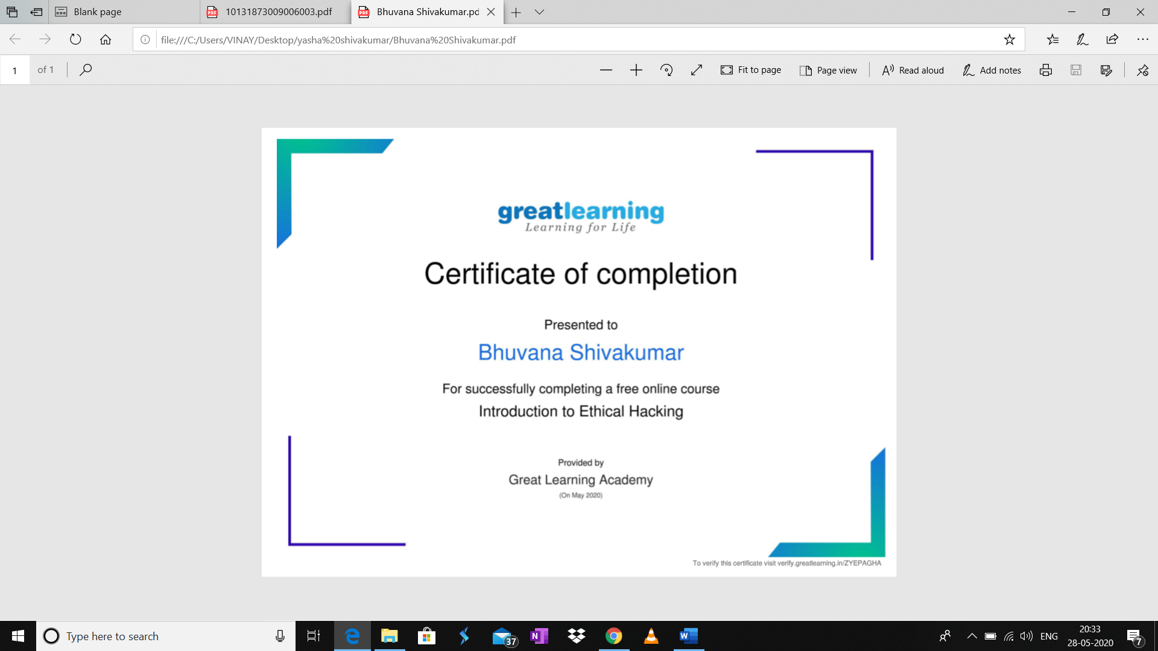

**Online Coding Challenge :**

**c++ prog to find sum of digits until the number is a single digits**

#include

using namespacestd;

intmain()

{

intnumber=147;

//Any number.intres;

if(number) res=number%9==0?9:

number%9;

else res=0;

//print the result cout<<res;

Return 0;

}

**v**